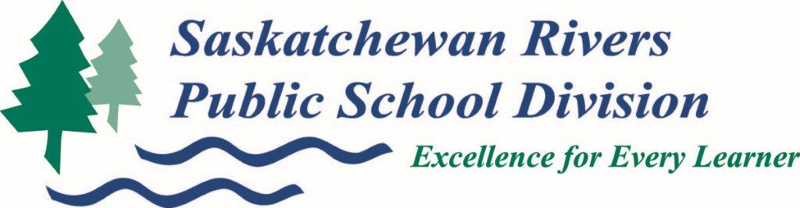

Saskatchewan Rivers Public School Division school bus notifications using Remind is the easiest and fastest way to get important information about your child’s school bus.

Remind is a free service that will enable you to receive our notifications by app or by text.

How To:

First sign up for our school division wide notifications following the simple instructions below. This is used to quickly communicate important information that affects the entire school division. This could include things such as mass cancellations or important updates on rules, school reminders and possible rule/regulation changes.

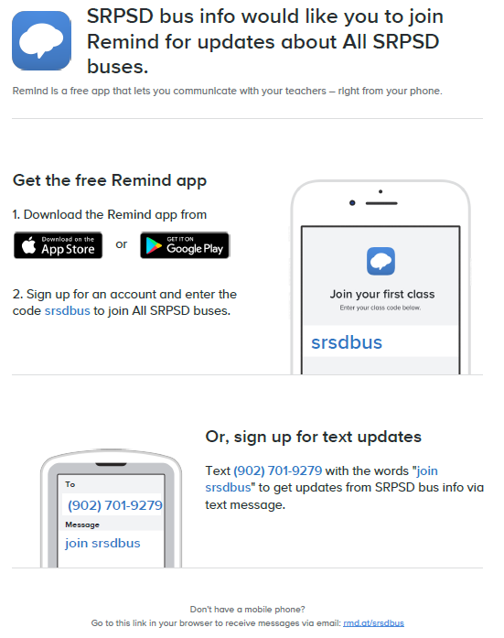

Now sign up for your **home school area** for the proper notifications.

XXXXX COPY AND PASTE YOUR SCHOOLS SPECIFIC INFO HERE XXXXX

If you have any questions, please call the Transportation Department at 306 763-2323 for assistance.